This media release is embargoed until 3 March, 10 a.m. CET


The MD 9235 microphone head is back
Sennheiser announces a fresh production run for its legendary capsule

Wedemark, 3 March 2026 – The MD 9235 microphone head for wireless handhelds has been a firm favourite with many engineers and artists for its ability to cut through high on-stage levels and reject crosstalk, even in front of the PA. When the cardioid mic head was discontinued a few years ago, some touring professionals remained attached to the 9235’s clear, detailed sound and excellent rejection, and repeatedly asked Sennheiser to reintroduce the capsule. Now the company is pleased to announce the return of the legendary MD 9235 wireless mic head.

“When the MM 435 mic head and the MM 445 high-rejection head suceeded the MD 9235 in 2020, they quickly built their own fanbase,” explains product manager Sebastian Schmitz. “But we still had enquiries for the MD 9235 coming in, even after years had passed since its discontinuation. So we sat together with our development and manufacturing engineers and examined how we could revive the 9325. We had samples thoroughly tested by several touring sound engineers and they were thrilled to have the MD 9235 back.”

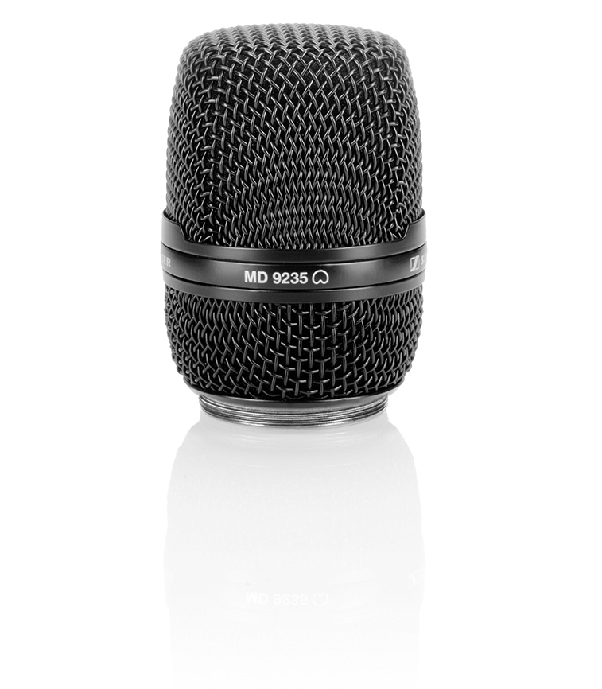 | Thanks to a fresh production run, the MD 9235 microphone head has returned into the Sennheiser portfolio

As before, the MD 9235 has been meticulously crafted to accurately and powerfully reproduce vocals while rejecting ambient noise from the sides and rear, making it the perfect choice for applications where the talent moves dynamically and often in front of the PA.

With its lightweight aluminium-copper microphone coil moving faster than conventional coils, the capsule delivers incredible detail and transparency even in the most challenging environments.

The MD 9235 retails at EUR 599 MSRP and is delivered complete with a pouch and five replacement foam inlays.

Technical Data
Microphone type: dynamic
Pick-up pattern: cardioid
Connector: Sennheiser standard capsule interface
Compatible with: Spectera, Digital 6000, Digital 9000, EW-DX, EW-D, EW-DP, 2000 series, evolution wireless G4 300 and 500 series
Frequency response: 40 – 20,000 Hz (+/- 2 dB)
Sensitivity: 1.8 mV/Pa (-54.9 dBV/Pa)
Max. SPL: 163 dB
Weight: 119 g
Diameter: 51 mm
Height: 72.5 mm

(Ends)

About the Sennheiser brand
We live and breathe audio. We are driven by the passion to create audio solutions that make a difference. Building the future of audio and bringing remarkable sound experiences to our customers – this is what the Sennheiser brand has represented for 80 years. While professional audio solutions such as microphones, meeting solutions, streaming technologies and monitoring systems are part of the business of Sennheiser electronic SE & Co. KG, the business with consumer devices such as headphones, soundbars and speech-enhanced hearables is operated by Sonova Holding AG under the license of Sennheiser.

www.sennheiser.com
www.sennheiser-hearing.com

Global Pro Audio Press Contact
Stephanie Schmidt
stephanie.schmidt@sennheiser.com
+49 (5130) 600 – 1275

